**Power Electronics**

**Professor G. Bhuvaneswari**

**Department of Electrical Engineering**

**Indian Institute of Technology, Delhi**

**Lecture 5 - Single Phase Uncontrolled Rectifiers**

(Refer Slide Time: 0:32)

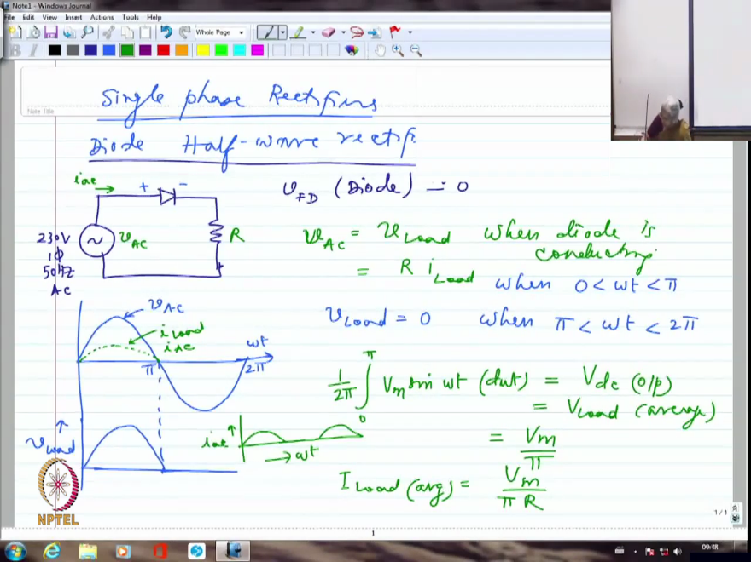

We are going to start on the power electronics circuits today. So, we will start off from single phase rectifiers. I am going to start off with the simplest of circuits, which is a diode half wave rectifier. And first to understand the basic working, I am going to explain it with resistive load, then we will go over to inductive load, then probably RLE load and so on and so forth. So, I am looking at a power supply which is normally 230 volts, single phase 50 hertz AC, this is what normally we use if we are talking about single phase AC.

So I am assuming that we are taking it from the power grid and here I am going to put the diode and here is the load, which is a resistive load. And when we consider the diode, compared to 230 volts, 0.7 volts is very very small. So I am literally going to take it as though it is ideal diode, hardly any voltage drop across the diode. So, diode voltage drop V forward voltage drop for the diode. I am assuming it to be approximately 0, I am not going to take into account 0.7 volts because compared to 230 volts AC, this is negligibly small.

Now, if I draw the waveform, I am going to have basically a sinusoidal voltage that is being applied to this particular diode circuit. So, diode will conduct whenever I am going to have positive here and negative here. When it is forward biased, it is going to conduct and that will happen only during positive half cycle. So, I am going to have essentially conducting exactly at the beginning of the positive half cycle assuming that the forward voltage drop is negligible, forward biasing voltage I am assuming almost as 0 volts.

Of course, you require 0.7 but I am assuming that that is negligible, so I am going to have the diode conduct and I am going to have the diode stop conducting exactly at this point, so this is actually the current I. So, the current is exactly going to follow the wave shape of voltage itself, there is hardly any difference because I am going to have essentially V, if I call this as VAC, so I should say VAC = Vload when diode is conducting, which is also incidentally equal to Riload, if I me call this as R.

So, because of which iload is going to be, whatever is my VAC/R, so the wave shapes are exactly similar. And if I try to look at the load voltage, I am going to have exactly until here the load voltage will appear and after that it has to be 0 (Vload=0). This is how the voltage has to be, I have to essentially 0 voltage whenever it is reverse biased. So, this is between when $ωt$, if I say this is $ωt$, then 0 to $ωt$ until $π$ and I am going to have Vload equal to 0, then $ωt$ is between $π$ and 2 $π$.

So, this is going to be the load voltage. I should say this is supply voltage and this is load voltage. And this is $π$ and this is 2 $π$. So, I can calculate of course, you guys might have done it already in some other course that is,

$\frac{1}{2π}\int_{0}^{π}{{(V}_{m}sinωt)dωt }$ =Vdc (o/p)

=Vload (average)

= $\frac{V_{m}}{π}$

This is going to be the value of voltage that I am getting from the half wave diode rectifier, provided I have a resistance load. And if I try to look at, Im or Iload (avg)= $\frac{V_{m}}{πR}$. Because it is only related by the resistance, nothing more than that. So, obviously although this is an average DC voltage, that is DC component as well as AC component, I am not going to have the voltage completely steady, it is continuously oscillating. In fact it is going from 0 value to peak value and again 0 value and persists at 0 value for another half cycle.